**Monte Carlo integration**

Monte Carlo integration is the simplest of a wide range of "Monte Carlo methods", where averages are calculated using uniform random sampling (in other Monte Carlo methods the sampling can be biased in various ways for increased efficiency).

Monte Carlo integration is based on the simple fact that an integral can be expressed as an average of the integrand over the range, or volume, of integration, e.g., a one-dimensional integral can be written as

$$A=\int_{a}^{b}{f\left(x\right)dx=\left(b-a\right)〈f〉 },$$

where $〈f〉$ is the average of the function in the range $[a,b]$. A statistical estimate of the average can be obtained by randomly generating $N$ points $a≤x_{i}≤b$ and calculating the arithmetic average

$$\overline{f}=\frac{1}{N}\sum_{i=1}^{N}{f(x_{i})}$$

This estimate approaches the true average $〈f〉$ as $→∞$, with a statistical error (to be defined precisely below) which is proportional to $1/\sqrt{N}$. In one dimension, this rate of convergence is very slow compared to standard numerical integration methods on a mesh using N points. However, in higher dimensions the computational effort of numerical integration increases exponentially with the number of dimensions, whereas the error of the Monte Carlo estimate for an integral in any number of dimensions decreases as $1/\sqrt{N}$. Hence, for high-dimensional integrals Monte Carlo sampling can be more efficient.

**Computation of $π$**

A good illustration of this method of repeated random sampling and averaging is the computation of the number $π$.

The basic idea is rather simple: We consider the unit area ( $x∈[0,1]$ and $∈[0,1]$) and compare the area within the quarter circle, $P(x,y)$, to the area of the unit square (see Fig. 4.1). This will give $\frac{π}{4}$.

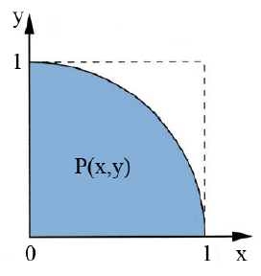

Figure 1: Illustration of the areas considered in the computation of π.

This relation is mathematically exact and can be expressed as an integral in the following way:

$$π=4\int_{0}^{1}{\sqrt{1-x^{2}}dx}$$

Another way to compute $π$ though (and learn something about Monte Carlo at the same time) goes as follows: We consider $N$ random points in the unit square that are characterized by their $x$ and $y$ coordinates $x_{i},y_{i}$. Then, the number of points $N_{c}$ lying within the quarter circle (i.e. fulfilling the relation $x^{2}+y^{2}≤1$) is compared to the total number N of points and the fraction will give us an approximate value of $π$:

$$π\left(N\right)=4\frac{N_{c}\left(N\right)}{N}$$

Of course, the more points we consider, the better the approximation will become.

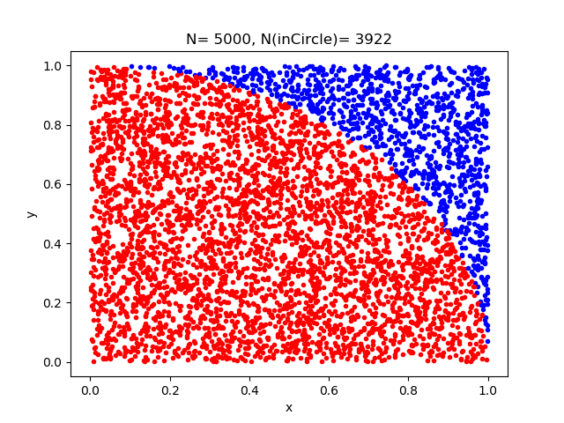

Figure 2: Illustration of the Monte Carlo integration method for finding the area of a quarter circle. With the quarter enclosed by unit square, the fractional area inside the circle is estimated by generating random points inside the square and counting the number of points that fall inside the quarter circle. In the case shown, 5000 points were generated (red points are inside the quarter circle, and the blue points are outside the quarter circle), and the fraction of points inside the circle is 0.784, which hence is the estimate of $\frac{π}{4}$ (which gives 3.137 for ) obtained in this calculation.

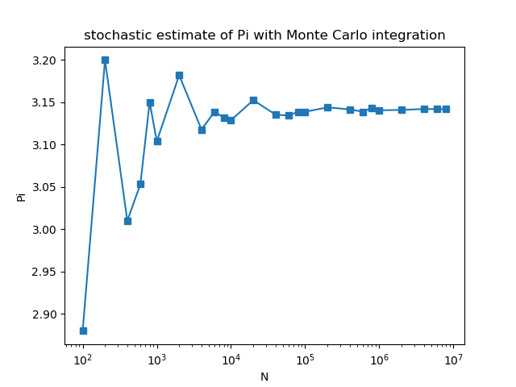

Figure 3: the stochastic estimate of $π$ as a function of number of points generated in Monte Carlo integration.

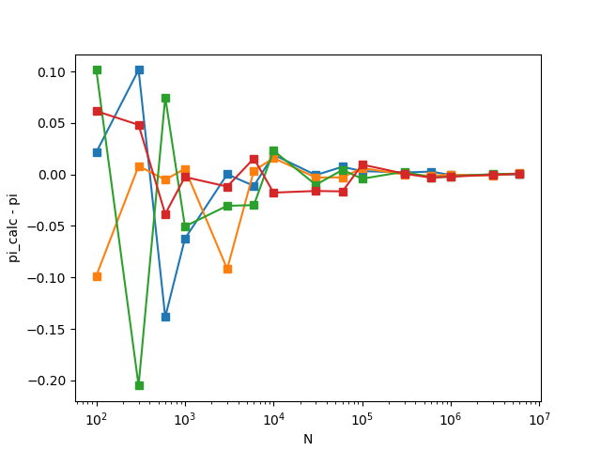

Figure 4: Deviation of the stochastic estimate of $π$ from the exact value as a function of the number of points generated in four independent Monte Carlo integration runs.